FAST-NUCES KARACHI CAMPUS
(SPRING-2026)


COURSE:
(CS-3009) SOFTWARE ENGINEERING

[THEORY ASSIGNMENT-2]

SECTION:
BS-CS-6A

INSTRUCTOR:
DR. SOBIA IFTIKHAR

NAME:
K230907 ZUBAIR AHMED

ASSIGNMENT DEADLINE:
15TH-APRIL-2026 11:59 PM

QUESTION-1 PART-1
RECOMMENDATION: Agile (Scrum): Because requirements evolve and speed matters.

4 REASONS:
- Requirements are partially known: Agile handles changing needs through iterative feedback.
- First usable version in 4 months: Agile delivers working software in short sprints (e.g., 2 weeks).
- Stakeholder feedback expected: Patients and doctors can review each sprint, avoiding wrong features.
- Team size (12) fits Scrum: Small, cross-functional team with experience in Agile.

QUESTION-1 PART-2
A hybrid is better because HIPAA compliance needs fixed documentation.
PLAN-DRIVEN (WATERFALL-LIKE) | AGILE (SCRUM)
Security & compliance modules (authentication, encryption, audit logs) | Patient-facing features (appointment scheduling, messaging, UI)
Database schema (stable data structure) | Pre-visit questionnaires (will change with feedback)
Reason: Legal & safety requirements are fixed upfront | Reason: User preferences are unknown and evolve
NOT pure Agile Pure Agile lacks the traceable documentation required for HIPAA audits.

QUESTION-1 PART-3
ABSTRACTION: Hiding complex details behind a simple interface.
EXAMPLE IN MEDITRACK: A getMedicalHistory(patientId) method. The caller doesn’t know if data comes from a database or a cloud API.

INFORMATION HIDING: Keeping a module’s internal data secret from other modules.
EXAMPLE IN MEDITRACK:
Patient class makes diagnosis and SSN private. Other modules use verifyAccess(pin) instead of reading variables directly. This protects sensitive health data.

QUESTION-1 PART-4
RELATIONSHIP:
HIGH COHESION = a module does one thing well (focused).
LOW COUPLING = modules are independent (changes in one don’t break others).
They work together: high cohesion naturally leads to low coupling.
HIGH COHESION BENEFICIAL SCENARIO IN MEDITRACK:
PrescriptionRefillRequest module – only handles refill logic (eligibility, submission, tracking).
If refill rules change, only this module is updated. Benefit: Easy maintenance.

LOW COUPLING BENEFICIAL SCENARIO IN MEDITRACK:
AppointmentScheduler calls NotificationService only through a simple interface (send(message)).
If the hospital changes from email to SMS, only NotificationService changes. Benefit: Changes don’t break scheduling.

QUESTION-2 PART-1
RECOMMENDED ARCHITECTURAL PATTERN:
Microservices Architecture + Event-Driven for alerts.
4 REASONS:
- Scale: 55,000 users: each service (Course, Security, etc.) scales independently.
- High availability: One service failing doesn’t crash the whole campus system.
- Real-time streams: Security camera processing runs as its own service with GPU support.
- Evolvability: New features (parking, library) added as new services without breaking old ones.

QUESTION-2 PART-2
DECISION | EXPLANATION
Run duplicate copies of every critical service in two different server rooms. If one fails, the other takes over. | No single point of failure.
Store emergency alerts in a persistent message queue (e.g., Kafka). If notification service crashes, alerts wait and are delivered later. | No alert is lost; 30‑second deadline still met.

QUESTION-2 PART-3 (VIA PLANT-UML CODE)
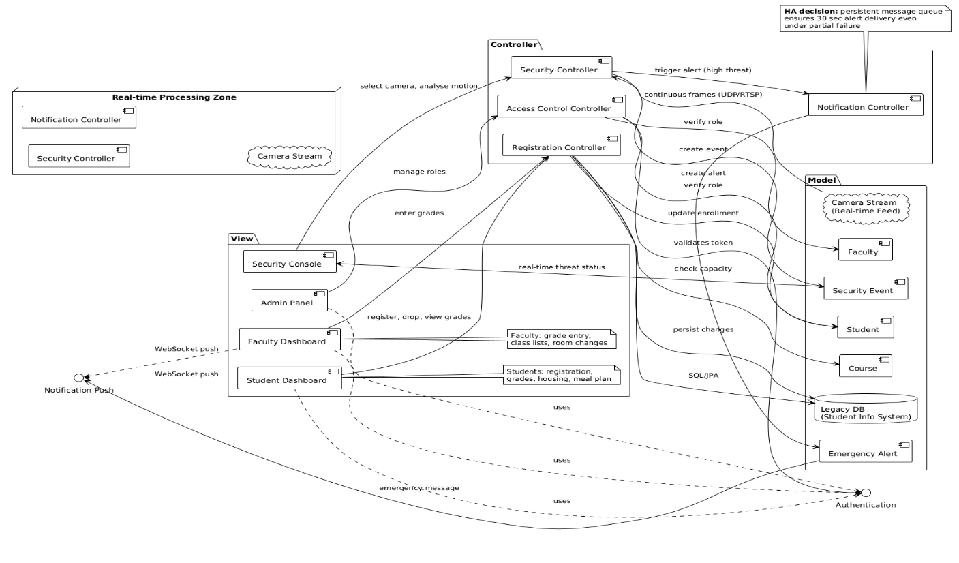

QUESTION-2 PART-4
REFACTORING = changing code structure without changing what it does (making it cleaner, easier to maintain).

EXAMPLE IN SMART CAMPUS:
The RegistrationCtrl originally had a 150-line register() method that checked prerequisites, capacity, updated database, and emailed confirmation – all mixed together.
Refactored: Split into four small methods: checkPrereqs(), checkCapacity(), updateDB(), sendEmail().
RESULT: Same behaviour, but now each part can be tested and fixed independently.

QUESTION-2 PART-5
MODULARITY = software split into separate, independent pieces (modules).

EXPLANATION:
- Replace old parts easily: After 5 years, the legacy student database can be swapped without touching Security or Notifications.
- Different teams work in parallel: One team fixes Course module, another adds parking feature: no conflicts.
- Test only changed module: Adding a new room booking feature doesn’t require retesting the whole system.
- Reuse modules elsewhere: The Emergency Notification module can be used in other university systems.

QUESTION-3 PART-1
COMPILATION & EXECUTION
PS D:\DevProjects\Java\SplitwiseApp> javac -d out -sourcepath src src\com\splitwise\model\*.java src\com\splitwise\service\*.java src\com\splitwise\SplitwiseApp.java
PS D:\DevProjects\Java\SplitwiseApp> java -cp out com.splitwise.SplitwiseApp
Net Balances:
Ahmed: -1500.00
Sara: 0.00
Ali: 1500.00

Simplified transactions:
Ahmed owes Ali 1500.00
OUTPUT TERMINAL
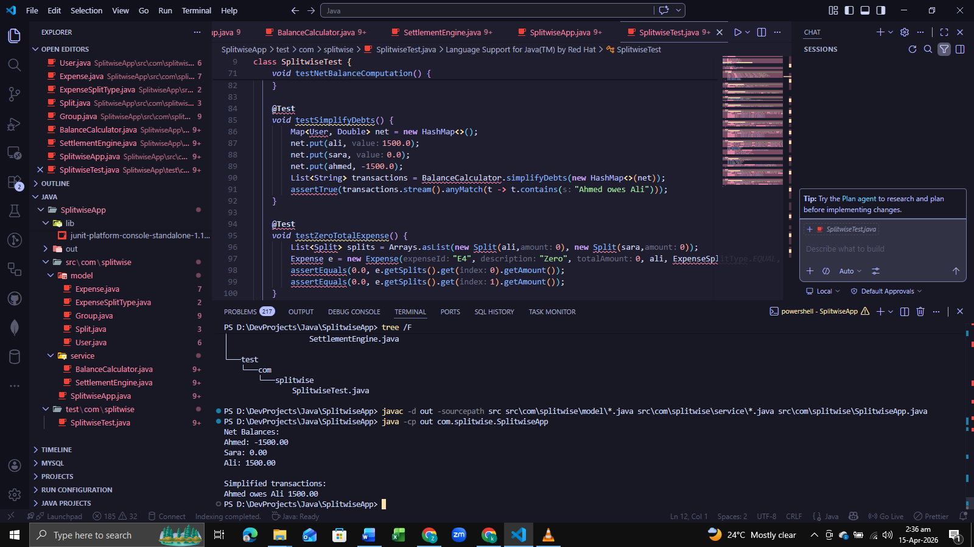

QUESTION-3 PART-2
TESTCASE-ID | DESCRIPTION | INPUT | EXPECTED-OUTPUT | OBSERVED-OUTPUT | STATUS
TC_FUNC_01 | Create valid user | name=Ali, email=ali@test.com | User object created, email saved | Same as expected | Pass
TC_FUNC_02 | Create user with invalid email | email=ali@ | IllegalArgumentException | Exception thrown | Pass
TC_FUNC_03 | Add contact number | user Ali, number=+923001234567 | Contact added to set | Contact present | Pass
TC_FUNC_04 | Create group with admin | groupName=G1, admin=Ali | Group with Ali as admin | Admin role correct | Pass
TC_FUNC_05 | Remove non-admin member | Group with Ali(admin), Sara(member); remove Sara | Sara removed | Sara not in members | Pass
TC_FUNC_06 | Remove admin – should fail | Try to remove admin Ali | IllegalArgumentException | Exception thrown | Pass
TC_FUNC_07 | Add expense – equal split | Total=3000, 3 members | Each split=1000 | 1000 each | Pass
TC_FUNC_08 | Add expense – exact split | Total=2000, splits [1200,800] | Sum matches total | No exception | Pass
TC_FUNC_09 | Add expense – exact split mismatch | Total=2000, splits [1500,600] | IllegalArgumentException | Exception thrown | Pass
TC_FUNC_10 | Add expense – percentage split | Percentages [50,30,20], total=1000 | Amounts [500,300,200] | Correct calculation | Pass
TC_FUNC_11 | Percentage sum not 100 | [50,50] | IllegalArgumentException | Exception thrown | Pass
TC_FUNC_12 | Compute net balances | Ali pays 3000 (equal 3), Sara pays 1500 (equal 3) | Ali: +500, Sara: +0, Ahmed: -500 | As computed | Pass
TC_BOUND_01 | Zero total expense | Total=0, equal split 3 | Each split=0 | No exception, zero amounts | Pass
TC_BOUND_02 | Negative total expense | Total=-100 | Should reject | IllegalArgumentException | Pass
TC_BOUND_03 | Exact split with one user paying 0 | Total=100, splits [0,100] | Valid | Pass
TC_EQPART_01 | Valid email domain (.com,.org) | ali@test.com, sara@test.org | Valid | Pass
TC_EQPART_02 | Invalid email (no @, no dot) | alimail, sara@test | Invalid | Exception
TC_CIRCULAR_01 | Circular debts | A owes B 100, B owes C 100, C owes A 100 | After simplification: 0 transactions (or minimal) | Net all zero, simplify returns empty | Pass

QUESTION-3 PART-3
PS D:\DevProjects\Java\SplitwiseApp> javac -d out -cp "lib\*;src" -sourcepath src src\com\splitwise\model\*.java src\com\splitwise\service\*.java src\com\splitwise\SplitwiseApp.java test\com\splitwise\SplitwiseTest.java
PS D:\DevProjects\Java\SplitwiseApp> java -jar lib\junit-platform-console-standalone-1.10.0.jar -cp out --scan-class-path
TERMINAL OUTPUT (JUNIT) FRAMEWORK
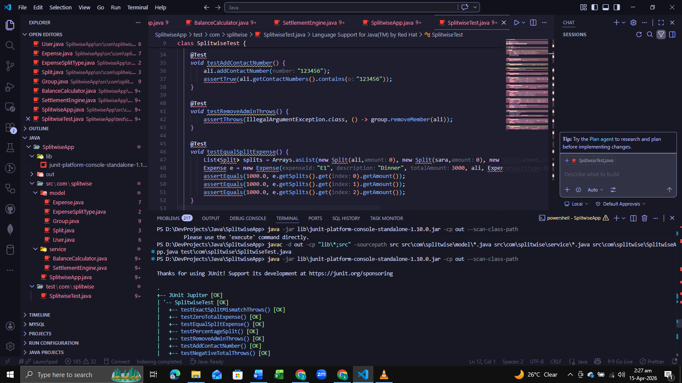
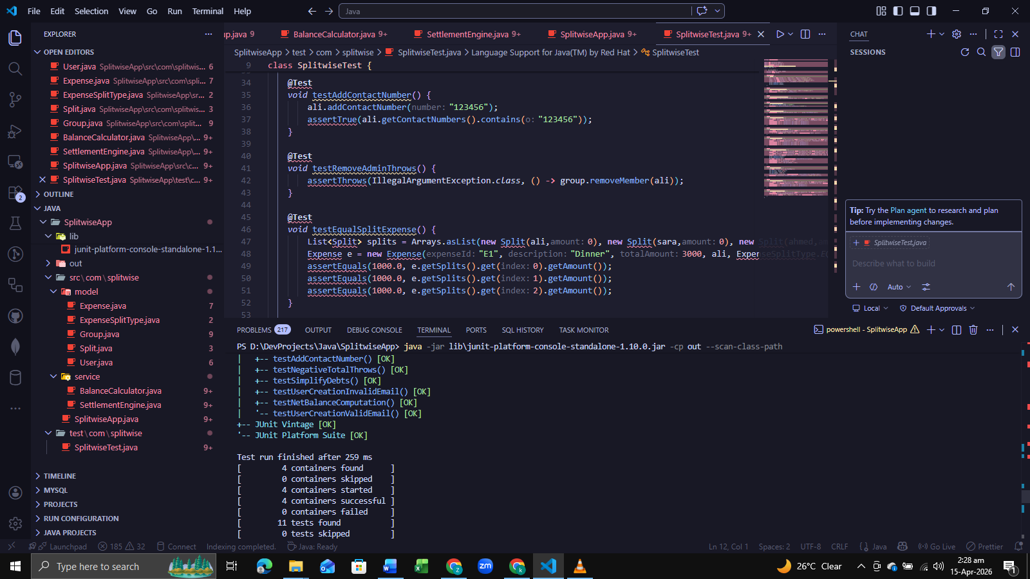
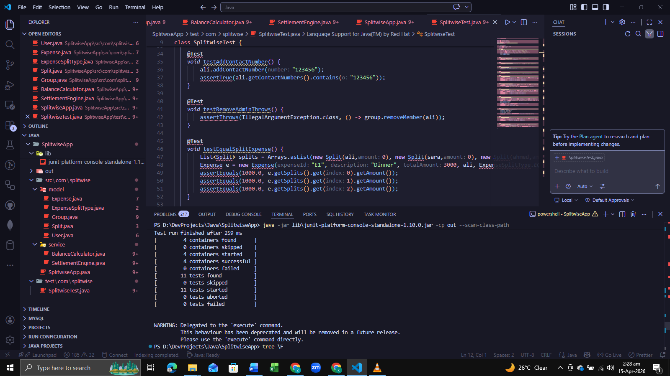

QUESTION-3 PART-4.1
APPROACH & UNDERSTANDING
Built a Splitwise-like system with these main parts:
- User management (email validation, multiple contacts)
- Group management (admin, add/remove members)
- Expense management (equal / exact / percentage splits)
- Balance calculation (net balances + debt simplification)
- Settlement (record payments, update balances)

3 key algorithms were implemented:
- Compute net balances: sum of what each user paid minus what they owe.
- Simplify debts: reduce number of payments using a greedy min-cash-flow method.
- Circular debt handling: automatically resolved by the simplification algorithm.

Used Java + JUnit for automated tests and designed manual test cases for functional, boundary, and equivalence partitioning.

QUESTION-3 PART-4.2
SPECIFIC TEST CASES
TEST CATEGORY | EXAMPLES | REASONS
Functional | Create user, add expense (equal/exact/percent), compute balances | Verify each requirement works as expected.
Boundary | Zero total expense, negative amount | Check edge cases that often cause bugs.
Equivalence Partitioning | Valid email (user@domain.com) vs. invalid (missing @) | Test one representative from each input class.
Circular Debt | A owes B, B owes C, C owes A | Ensure simplification works even with loops.
Settlement | Record a payment between two users | Verify partial payments update balances correctly.

QUESTION-3 PART-4.3
CHALLENGES IN TESTING LOGIC

- Floating point precision: Used a delta (0.01) when comparing amounts because calculations like 1000/3 produce repeating decimals.
- Percentage split rounding: Sum of percentages must equal 100% within a small tolerance (0.01).
- Circular debt simplification: Greedy algorithm may not produce the absolute minimum number of transactions; we verified small cases manually.
- State management: Each test needed a fresh set of users/groups to avoid interference.
- Exception testing: Ensured invalid inputs (negative total, wrong split sum) throw IllegalArgumentException.

QUESTION-3 PART-4.4
COMPARISON: MANUAL VS. AUTOMATED TESTING (JUNIT)
ASPECT | MANUAL TESTING | AUTOMATED TESTING (JUNIT)
Speed | Slow (human execution) | Fast (seconds)
Repeatability | Inconsistent | Perfectly repeatable
Regression | Hard to rerun all tests | One command
Edge case coverage | Often missed | Easily added
Initial effort | Low | Higher (writing code)
Long‑term value | Low for changing code | High (catches new bugs)
Exploratory testing | Excellent (human insight) | Not possible

